**Q5: Stock Span Problem**: Solve the **Stock Span Problem** using a **stack**, where for each day’s stock price, you calculate the number of consecutive days the price was less than or equal to today’s price.

<!DOCTYPE html>

<html lang="en">

<head>

<meta charset="UTF-8">

<meta name="viewport" content="width=device-width, initial-scale=1.0">

<title>Stock Span Problem</title>

<style>

body {

font-family: Arial, sans-serif;

display: flex;

justify-content: center;

align-items: center;

height: 100vh;

margin: 0;

background-color: #f4f4f9;

}

.container {

background: #ffffff;

padding: 20px;

border-radius: 10px;

box-shadow: 0 4px 8px rgba(0, 0, 0, 0.1);

text-align: center;

width: 400px;

}

input, button {

padding: 10px;

margin: 10px 0;

border: 1px solid #ddd;

border-radius: 5px;

width: 100%;

}

button {

background-color: #007BFF;

color: white;

cursor: pointer;

}

button:hover {

background-color: #0056b3;

}

.output {

margin-top: 20px;

text-align: left;

}

.output p {

padding: 8px;

background-color: #f9f9f9;

border: 1px solid #ddd;

border-radius: 5px;

}

</style>

</head>

<body>

<div class="container">

<h1>Stock Span Problem</h1>

<input type="text" id="pricesInput" placeholder="Enter stock prices (comma-separated)">

<button id="calculateSpan">Calculate Stock Span</button>

<div class="output">

<h3>Stock Span Result:</h3>

<div id="output"></div>

</div>

</div>

<script>

// Function to calculate stock span

function calculateStockSpan(prices) {

const span = [];

const stack = []; // Stack to keep track of indices

for (let i = 0; i < prices.length; i++) {

// Pop elements from stack while the current price is greater

while (stack.length > 0 && prices[stack[stack.length - 1]] <= prices[i]) {

stack.pop();

}

// If stack is empty, all previous prices are smaller

span[i] = stack.length === 0 ? i + 1 : i - stack[stack.length - 1];

// Push the current index onto the stack

stack.push(i);

}

return span;

}

// Handle button click

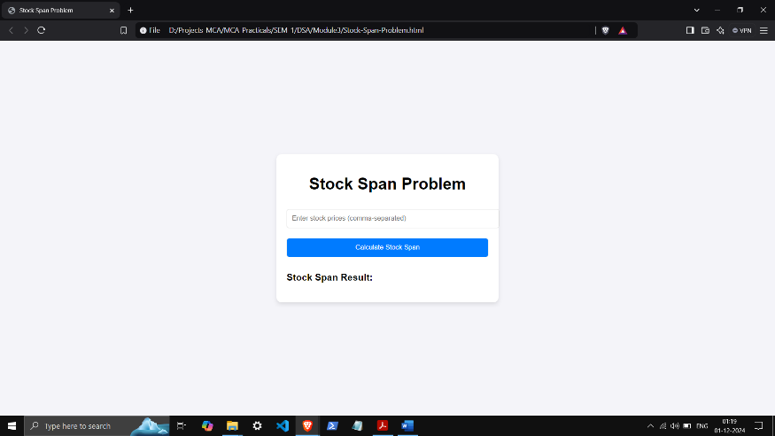 document.getElementById("calculateSpan").addEventListener("click", () => {

const pricesInput = document.getElementById("pricesInput").value.trim();

if (!pricesInput) {

alert("Please enter stock prices.");

return;

}

const prices = pricesInput.split(",").map(Number);

if (prices.some(isNaN)) {

alert("Please enter valid numbers separated by commas.");

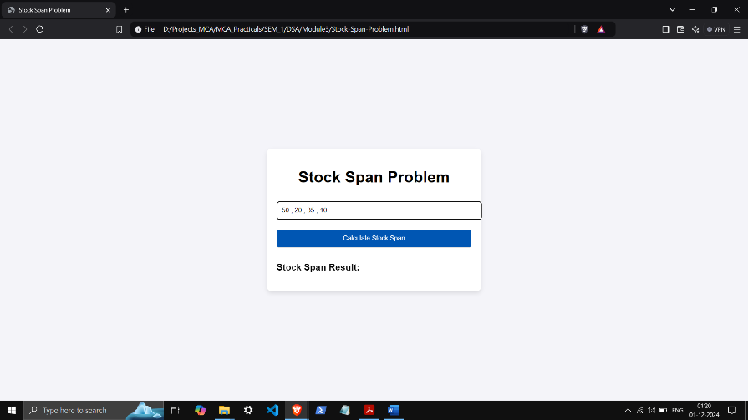 return;

}

const span = calculateStockSpan(prices);

// Display the result

const output = document.getElementById("output");

output.innerHTML = prices

.map((price, index) => `Day ${index + 1} (Price: ${price}): Span = ${span[index]}`)

.join("<br>");

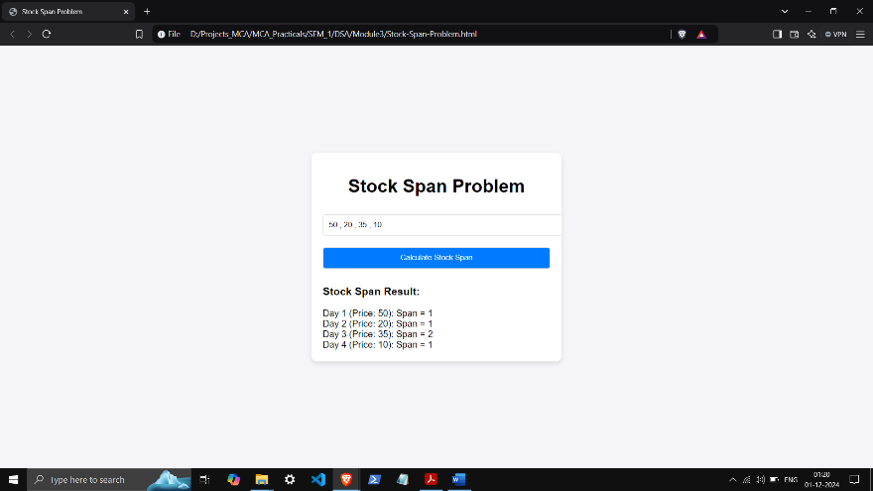 });

</script>

</body>

</html>